Microcanonical-sampled Master Equation Overestimates Macroscopic Rate Constants in a Kinetic Ising Model

Daniel Sigg,^{1,a)} Vincent Voelz,² and Vincenzo Carnevale ^{3,b)}

¹dPET, Spokane, WA 99223, USA
²Department of Chemistry, Temple University, Philadelphia, Pennsylvania 19122, USA
³Institute for Computational Molecular Science, College of Science and Technology, Temple University, Philadelphia, Pennsylvania 19122, USA
Diffusion across a free energy landscape is a widely used phenomenological approach to modeling kinetics in fluctuating molecules such as proteins, where coarse-graining is necessary to reduce the state space to a manageable size. Here we compare native barrier transition rates from a kinetic Ising model with those calculated from a coarse-grained master equation whose rate constants are averaged over the microcanonical ensemble and adapted to other ensembles in one and two dimensions. The calculated rates were roughly 50% larger than the native rates for a range of environmental constraints, suggesting there is a systematic impediment of configurational progress on the microscopic scale that is specific to the structure of the Ising model. The overestimation of macroscopic rate constants represent a failure of the thermodynamically exact microcanonical coarse-graining method in our simple model. This raises the question of whether kinetic coarse-graining in more complex systems such as proteins can be reliably performed, particularly in the calculation of the diffusion coefficient.

_____________________________
- Electronic mail: dansigg@gmail.com
^{b)} Electronic mail: vincenzo.carnevale@temple.edu

I. INTRODUCTION
The kinetics of small systems are dominated by large-scale fluctuations. This is evident in single molecule recordings of proteins and other biological macromolecules. An example of a functionally relevant protein fluctuation is the gating transition between conductance states in an ion channel. Channel gating is temperature-dependent and is also sensitive to other environmental variables such as voltage and ligand concentration (Zheng and Trudeau, 2015). Computer simulations of protein dynamics have benefited from enhanced methods that sample the accessible state space in a reasonable time (Harpole and Delemotte, 2017). Probability distributions obtained from simulation may be reformulated into low-dimensional free energy landscape (F), a coarse-graining process firmly rooted in statistical mechanics. By allowing Brownian motion across F, one obtains a phenomenological model of the kinetics. The diffusion coefficient (D) for such a kinetic model may be obtained from the same simulation yielding F (Best and Hummer, 2010; Straub et al., 1987), although the theoretical basis for D is weaker than for F. Here we evaluate the accuracy of a coarse-graining procedure yielding F and D in a simple lattice model with known thermodynamic properties. Microscopic rate constants averaged over the microcanonical ensemble were used to construct a master equation for coarse-grained mesostates, from which macroscopic rate constants were calculated. The rate constants were compared to native transition rates obtained from unbiased Monte Carlo simulations, and were found to be about 50% larger. The source of the discrepancy is conjectured to be a mild form of “frustration” that prevents a subset of microscopic states in any mesostate from transitioning forward, thereby lengthening native trajectory pathways.
II. THEORY
- Electrical Ising model
We chose as our system an electrical variant of the traditional Ising model. The model describes a square lattice of N locally interacting particles that responds to an applied voltage V rather than the magnetic field H of the traditional model. The internal energy E of the electrical Ising model is:
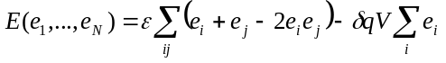, (1)
where i runs over all particles and ij denotes nearest neighbors. Particle states are e_{i} = 0 (resting) and 1 (active). Every activating particle moves a small “gating” charge δq modeled after gating currents in voltage-gated ion channels. The internal energy of the Ising model increases in increments of 2ε from a minimum of 0 (uniform grid) to a maximum of 2Nε (checkerboard pattern of activation), where ε is the inter-particle energy. The order parameter q is the total charge displacement:
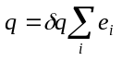, (2)
whose value ranges from 0 to Nδq. The electric and magnetic Ising models are entirely isomorphic. One model can be converted to the other with: s_{i} ↔ 2e_{i} – 1, ε ↔ 2J, δq ↔ 2μ, and V ↔ H, where the magnetic variables are the particle states s_{i} = ±1, coupling energy J, magnetic moment μ, and field H.
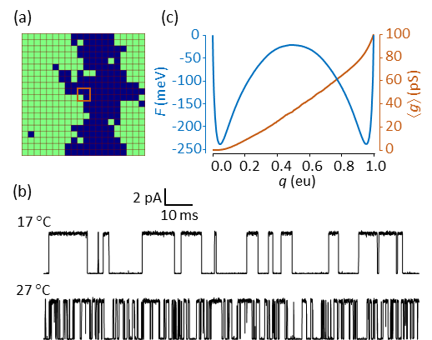
FIG. 1. (a) 20 x 20 Ising model. Green cells indicate activated particles. The central brown square is a 2 x 2 “pore”, where the instantaneous conductance g (not to be confused with density of states) is assumed to be proportional to the number of activated particles (0 to 4) within the pore. (b) Native Monte Carlo simulations of the single channel current i = g(V – V_{rev}) at two temperatures. V = 0 mV; V_{rev} = –60 mV. The current was filtered with a cutoff frequency of 10 kHz and sampled at 100 kHz. There was no added noise. (c) 1D free energy landscape F(q) and mean conductance ⟨g(q)⟩ obtained from time averaging over a 0.4 s simulation at 17 °C.
Simulated trajectories of the electrical Ising model are qualitatively similar to laboratory-generated traces from voltage-gated ion channels (Fig. 1b). Both demonstrate stochastic switching between macrostates. We made no attempt at a realistic depiction of channel gating; instead, the aim was to test whether slow barrier kinetics were preserved after coarse-graining to a diffusion landscape. There are practical advantages to using the Ising model rather than performing detailed molecular dynamics simulations of a protein such as an ion channel: (1) There is no inertial memory in Ising dynamics, obviating the need for a time-dependent diffusion coefficient; (2) Particle interactions are nearest-neighbor and regular, allowing rapid calculation of kinetics and long-term trajectories; (3) The Ising system is bounded in E and N, and its thermodynamics can be fully described using the microcanonical ensemble; (4) Microscopic rates can be averaged over the microcanonical ensemble; (5) Coarse-grained kinetics are expressible in the form of a master equation that can be solved numerically.
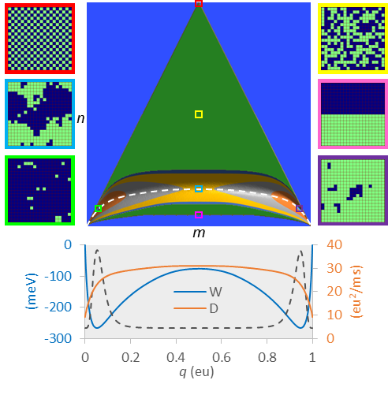
FIG. 2. Course graining the 20 x 20 electrical Ising model (N = 400). The green triangle is the set of all accessible (m, n) states (= 73,448). The 2D contour region at the base of the triangle is the reaction pathway comprised of a reduced number of states (= 22,149) constrained by F < F_{max}, under conditions: T = 22 °C, V = 0 mV, and F_{max} = 150 meV. The reaction pathway has maximum vertical span (bandwidth) of 68 cells at the separatrix. The dashed white line is the mean energy ⟨E(q)⟩. On the sides of the figure representative microscopic configurations are shown for: maximum energy (red); maximum entropy (yellow); saddle point region (blue); minimum transition state energy (pink); minimum free energy in state 1 (green) and in state 2 (purple). The projected 1D landscapes F(q) and D(q) are plotted at bottom, along with the equilibrium probability distribution P(q) (dotted line).
The coarse-graining procedure is illustrated in Fig. 2. Representative examples of the 2^{N} microscopic configurations are shown for a 20 x 20 Ising model (N = 400). Theoretically, microscopic dynamics are governed by a master equation, albeit a difficult one to solve due to the vast number of microstates. We binned the microstates onto a more manageable N x N mesoscopic grid containing the microcanonical density of states g(q, E) (Pleimling and Behringer, 2005). Each mesostate (q, E) corresponds to an integer pair (m, n), where q = mδq and E = 2nε. The state space of the Ising model with periodic boundaries is an equilateral triangle with a concavity at the base. The height of the concavity is 2N^{½}ε, giving rise to the well-known symmetry-breaking properties of the 2D Ising model. The purpose of coarse-graining was to construct a mesoscopic master equation whose smallest non-zero eigenvalue is the macroscopic relaxation rate.
Since realistic simulations are run at constant temperature and voltage, a free energy landscape F(T, V) on the (m, n) grid was constructed from g(q, E), written g_{mn} in integer notation.
. (3)
F_{nm} is a potential of mean force (pmf) with respect to the discrete variables m and n, but for large enough N, it is effectively a smooth function of q and E. For positive values of ε, only a lower portion of the triangle is appreciably populated (paramagnetism in the traditional Ising model). In order to limit the mesoscopic (m, n) states to a more manageable number, we established a cut-off value F_{max} chosen to be at least 6 kT greater than the saddle point energy between the two ordered states.
A second level of coarse-graining involved projecting the 2D landscape F_{nm}(T, V) onto a 1D pmf F_{m}(T, V) shown at the bottom of Fig. 2. The free energy projection is defined by:
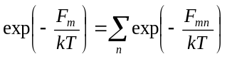. (4)
The 1D pmf has N + 1 states. The 1D and 2D pmfs provide exact thermodynamic information, though the 1D landscape is limited to functions of q. From the 2D landscape we can, using Boltzmann averaging, obtain heat capacities for different ensembles (Fig. 3a); these are less peaked than the infinite-particle Onsager solution around their respective “critical” temperatures. Both 1D and 2D pmfs yield the mean charge displacement ⟨q⟩, which is a steeper function of V at low temperatures (Fig. 3b).

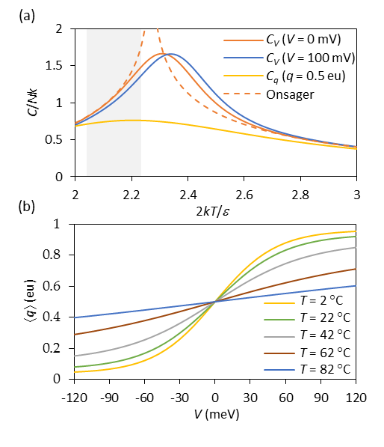
FIG. 3. (a) Heat capacities C of the 20 x 20 Ising model for constant V and q, as a function of normalized temperature. The dotted curve is the exact Onsager solution for an infinite system (Toda et al., 1992). The shaded region indicates the physiological range of T from 10 °C to 40 °C. (b) Mean charge displacement ⟨q⟩ versus V for temperatures indicated.
- Microscopic rates
In order to study dynamics we needed a model for microscopic rates. These are constrained by detailed balance:
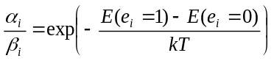, (5)
where α_{i} and β_{i} are the forward and backward rates associated with the activation of the i^{th} particle. We assumed barrier kinetics of the form:
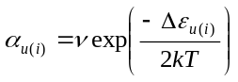, (6a)
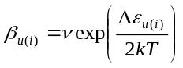 , (6b)
where ν is the pre-exponential factor and the energy of activation Δε depends on the number u(i) of neighboring activated particles, as follows:
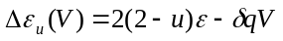 . (7)
There is nothing unique about our choice of microscopic rate constants. A different choice attributed to Glauber (Glauber, 1963) could be used if one wished to prevent the microscopic rate from exceeding ν.
Mesoscopic rates
There are ten possible microscopic rate constants arising from combinations of u (0…4) and e (0, 1). These correspond to the ten cardinal directions (five forward and five backward) available to an (m, n) state (Fig. 4). These mesoscopic rates have the form a_{kk′} = ⟨r_{kk′}⟩α_{u} (forward) and b_{k′k} = ⟨r_{k′k}⟩β_{u} (backward), where ⟨r_{kk′}⟩ is a statistical factor representing transition frequencies from states k = (m, n) to k′ = (m′, n′). Detailed balance in the microcanonical ensemble is described by ⟨r⟩_{kk′} g_{k} = ⟨r⟩_{k′k} g_{k′}. The averaging of microscopic rates on the mesoscopic scale is the critical step in successfully coarse-graining the system kinetics. Except for the simplest possible Ising scheme (N = 4), the mesoscopic rate constants a_{kk′} and b_{k′k} are Boltzmann-weighted averages over multiple microstates. Not every cardinal direction is accessible to a particular microstate, even if other microstates within the same k = (m, n) state can undergo the move. We’ll revisit this essential point in the Discussion section.
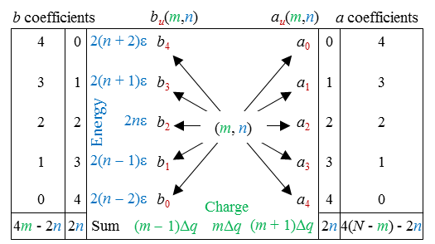
FIG. 4. Cardinal transitions from an (m, n) state. Relationships between the cardinal rates are expressed in the outer columns, where rate constants multiplied by the indicated coefficients sum to the expressions on the bottom row, accounting for four constraints on the kinetics. Detailed balance accounts for five additional constraints between opposing rates, expressed as: a_{u}/b_{u} = exp(−Δε_{u}/kT).
Projection of the 2D rate constants onto the m axis through Boltzmann averaging yielded the 1D rates a_{m} and b_{m}, or in continuous notation a(q) and b(q). In 1D, detailed balance assumes the form: a(q)exp(−F(q)/kT) = b(q + δq)exp(−F(q + δq)/kT). The 1D diffusion coefficient D(q) was obtained from the Brownian motion expression 2D(q) = [a(q) + b(q)]δq². The 1D dynamics can be expressed either through a_{m} and b_{m}, from which a master equation can be constructed, or through the landscape variables F(q) and D(q), which can be inserted into a Langevin equation. The two representations are equivalent for large systems, but because the Langevin equation is an approximation of the original master equation valid for small δq, we regularly used the master equation for our calculations. That said, predictions from Langevin simulation were not very different for the model sizes considered (N ≥ 256).
Apart from coarse-graining using the microcanonical ensemble, an alternative method for determining the 1D landscape variables F(q) and D(q) (or equivalently, a_{m} and b_{m}) for a particular set of environmental constraints was through native kinetic simulation of the Ising model. This is significant since time averaging under conditions of constant temperature, pressure, and other environmental constraints, is the usual procedure for determining parameter values in a complex system like a protein. For the 1D Ising representation, we obtained F(q) to within a constant value C by evaluating −kTlnP(q) over a very long trajectory, where P(q) is the time-averaged probability of being in the state q. The value of C was fixed using the boundary condition F(0) = 0. In our simulations, 1D ensemble and time-averaged quantities superimposed neatly, confirming ergodicity. With some variables, such as the “pore” conductance shown in Fig. 1, ensemble averaging is not possible since conductance was defined with respect to specific microconfigurations and is not a function of q and E. With the time-averaging method, the diffusion constant D could be obtained for all values of q from mean values of the forward and backward rates using the earlier expression for Brownian motion, or by simulating the filtered capacity current i_{g} = dq/dt within a narrow q window centered at the barrier peak, and using Nyquist’s current theorem: 4kTB/R = ⟨i_{g}²⟩ (Sigg et al., 1999), where the resistance R is related to D through the Einstein equation DR = kT, and the recording bandwidth B is related to the Gaussian filter cut-off value through B = 1.064f_{c}. From a practical standpoint, the shape of D(q) is not very important as the macroscopic rate is essentially determined by the value of D at the barrier peak (Fig. 5). This is because in our system barriers were sufficiently large (≥ 6 kT) that basin states thermalized rapidly compared to the rate-limiting barrier outflow.
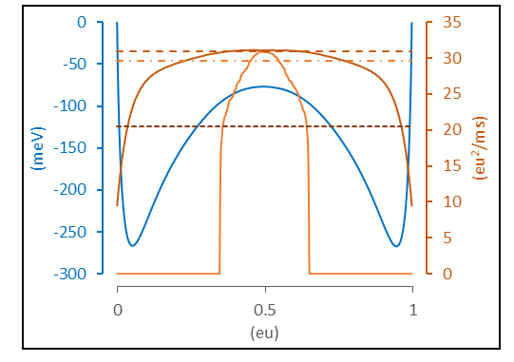
FIG. 5. Methods for calculating D. The dashed brown line represents the value of constant D (30.9 eu²/ms) yielding the same forward rate as the spatial diffusion coefficient D(q) (solid brown line) when both are applied to the coarse-grained pmf W(q). Short (1 ms) simulations performed with a sharp umbrella window in the barrier region (q = 0.35 eu to 0.65 eu) yielded an abbreviated D(q) (solid orange line; averaged from 500 traces). Nyquist’s theorem applied to high-bandwidth i_{g} fluctuations measured from the same data set predicted D = 29.1 eu²/ms (dot-dashed orange line). By comparison, the value of constant D conforming with native kinetics is only 20.5 eu²/ms (dark brown dotted line). Model parameters were: N = 400, T = 22 °C, V = 0 mV. Filter cut-off frequency for i_{g} simulations: f_{c} = 5 x 10⁵ kHz.
- Macroscopic rates
The final level of coarse-graining reduced the kinetics to forward and backward unidirectional rate constants between the two macroscopic states. Starting with the 1D and 2D free energy landscapes, we computed the rate constants k₁₂ and k₂₁ using three methods. In the first (eigenvalue) method, mesoscopic rates a, b were tabulated in a rate matrix Q constructed to satisfy the master equation dp/dt = pQ, where p(t) is the row vector of state probabilities (Sigg et al., 1999). The first non-zero eigenvalue of Q equals the sum k₁₂ + k₂₁. When necessary, the ratio k₁₂/k₂₁ was obtained using detailed balance so individual rates could be determined. This is necessary only if V ≠ 0; otherwise, symmetry requires k₁₂ = k₂₁. The second (mean first passage time) method involved truncating Q for q greater than q₂, the lowest free energy point of macrostate 2, thereby creating an invertible matrix Q′. The mean first passage time (MFPT) from q < q₂ to q₂ was obtained by solving Q′τ = u (Van Kampen, 1992), where τ is the column vector of MFPTs τ(q → q₂) and u is the unit vector. The quantity 1/τ(q₁→ q₂), where q₁ marks the minimum free energy of state 1, is an accurate estimate of the forward rate constant k₁₂ for sufficiently large barriers (≥ 6 kT) (Reimann et al., 1999). In the last (Monte Carlo) method, we constructed a coarse-grained master equation for the 2D mesoscopic rates on the (m, n) grid, and one for the projected 1D rates a_{m} and b_{m}, from which long (4 s) Monte Carlo simulations generated exact first passage times between q₁ and q₂, the averages of which yielded k₁₂ and k₂₁.
- Native Monte Carlo simulation
A continuous-time Monte Carlo algorithm for simulating the electrical Ising system at constant T and V was used to obtain precise first passage times from q₁ to q₂ for the native process. We obtained the inverse MFPT from thousands of recorded transitions and used this as the gold standard value for k₁₂, against which coarse-graining methods were judged. We could not verify the accuracy of the Monte Carlo method using independent methods, as we did for the 1D and 2D simulations. However, consistent outcomes were obtained using several “good” pseudorandom number generators (Fig. 6), suggesting the calculations were reliable.
III. NUMERICAL METHODS
The majority of Monte Carlo simulations and analysis routines were run on Temple University’s Compute server using customized software written in C. For each set of environmental conditions (N, T, V, F_{max}), six simulations ran simultaneously, comprising a single experiment. Each run generated the following: (1) the density of states g and transition frequencies ⟨r⟩; (2) 1D and 2D potentials of mean force and rate constants in the (N, T, V) ensemble; (3) simulated trajectories of the native process and coarse-grained master equation simulations in 1D and 2D; (4) mean first passage times for native, 1D, and 2D Monte Carlo simulations using direct observation, and for 1D and 2D master equations using the Q′ method; and (5) eigenvalue analysis for 1D and 2D master equations. Output parameters for each experiment were expressed as the mean and standard error from the six independent runs. We chose as the reference model the 20 x 20 Ising grid (N = 400) with the following parameters: T = 22 °C; V = 0; ε = 24 meV; q_{max} = 1 eu; and ν = 5 x 10⁴ kHz. We ran additional experiments with different T, V, and N to determine their effect on rate constants. A total of 15 experiments were performed for this paper. The values of ε, δq = q_{max}/N, and ν were the same for all experiments.
- Random number generators
We tested several pseudorandom number generators to address the possibility of biased sampling. These were: (1) Numerical Recipes© long-period L’Ecuyer generator with Bays-Durham shuffle (ran2) (Press et al., 1992); (2) Intel® MKL Library SIMD-oriented Fast Mersenne Twister (FMT) (Saito and Matsumoto, 2008); (3) Intel® MKL Library multiplicative congruential generator (MCG) (L’Ecuyer, 1999a); and (4) Intel® MKL Library combined multiple recursive generator (MRG) (L’Ecuyer, 1999b). Of the four generators, the MCG algorithm yielded outlying outcomes and greater variability than the other three (Fig. 6), and is not recommended for use in our model. Most simulations employed the ran2 algorithm. In a small number of cases involving large barriers where the performance of the random number generator was in doubt (for example, Fig. 6b), repeating the simulations using the FMT and MRG algorithms helped to confirm the results.
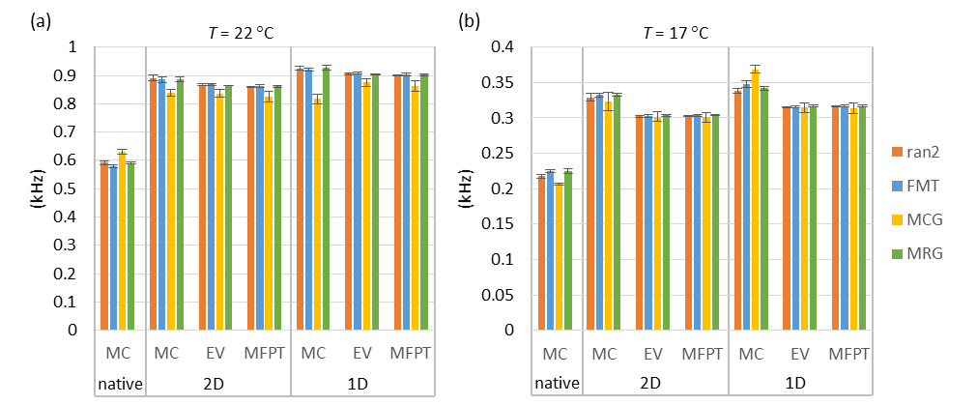
FIG. 6. Forward rate constant estimates (mean ± s.e., n = 6) from different methods (MC = Monte Carlo, EV = eigenvalue analysis, MFPT = mean first passage time) as a function of pseudorandom number generator. (a) Reference model. T = 22 °C. (b) Temperature lowered to 17 °C, which increased the barrier height and led to a discrepancy between Monte Carlo and the other two methods (EV and MFPT). Results were consistent between generators except in the case of the multiplicative congruential generator (MCG), which demonstrated lower accuracy and precision compared to the other three generators.
- Computing mesoscopic rates
The Metropolis Monte Carlo (MMC) method was used to compute average rates in the microcanonical distribution. Applying traditional MMC for infinite T and zero V allows every trial move to be accepted, in principle yielding the microcanonical ensemble. However, the large entropy gradient makes this algorithm impractical for all but the smallest systems, so a bias potential ω_{k} was applied to “flatten” the gradient and allow uniform sampling over all k = (m, n) mesostates. The 1/t variant of the Wang-Landau algorithm with endpoint F = 10⁻⁶ was used to rapidly obtain lnω_{k} (Belardinelli and Pereyra, 2007). MMC was then implemented by picking a random particle to flip, and after determining the locations of the current state k and the trial state k′ on the (m, n) grid, applying the following acceptance criterion for the k → k′ transition:
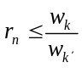, (8)
where r_{n} is a uniform random number from 0 to 1. For each discrete time point s, the ten cardinal rates a_{u} and b_{u} were determined by summing microscopic rates over all particle transitions. For example, if nine out of N particles contribute to the backward transition (u, v) → (u – 1, v + 2), then the instantaneous rate b₄(s) would be assigned the value 9β₄, where β ₄ is the corresponding microscopic rate (Eq. 6b). The starting configuration for each simulation run was chosen randomly. Following an equilibration period of 2 x 10⁶ points, time-averaged forward rates were obtained over 2 x 10¹⁰ time points using the following formula:
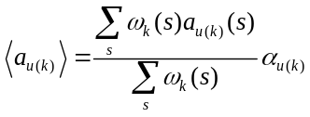, (9)
with a similar expression for reverse rates ⟨b_{u(k)}⟩. The ratio of sums in Eq. 9 is the mean transition frequency ⟨r_{kk′}⟩, which can be rewritten as ⟨r_{u(k)}⟩_{a}, and for the reverse transition as ⟨r_{u(k)}⟩_{b}. The microcanonical density of states was obtained from:
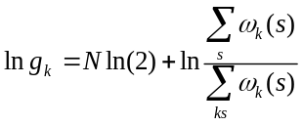. (10)
The density of states g_{k} and rate factors ⟨r_{u(k)}⟩_{a} and ⟨r_{u(k)}⟩_{b} were stored as N x N matrices lng, A_{u}, and B_{u} (Fig. 7). These eleven matrices are not independent (Fig. 4), but to avoid excessive sampling error, none were eliminated to reduce data storage. It should be emphasized that, like lng, A_{u} and B_{u} are statistical matrices that depend only on N. In order to calculate mesoscopic rate constants for any set of environmental conditions: T, V, and model parameters: ε, q_{max}, and ν, we applied: a_{u(k)} = ⟨r_{u(k)}⟩_{a}α_{u} and b_{u(k)} = ⟨r_{u(k)}⟩_{b}β_{u}, using Eqs. 6 and 7 for the microscopic rates α_{u} and β_{u}.
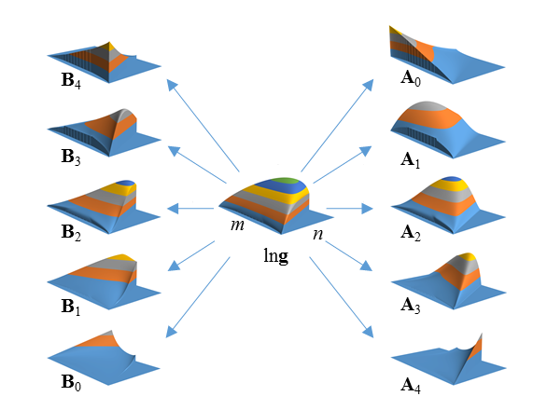
FIG. 7. Density of states (g) and cardinal rate (A, B) matrices for 20 x 20 Ising model. Vertical axes are not to scale. The n-axis was cut off at n = 254 due to limitations of the plotting software.
- Computing macroscopic rates
In order to compute macroscopic rates k₁₂ and k₂₁, a rate matrix Q was constructed. The upper diagonal terms of Q contained forward rates a_{u(k)} (2D) or a_{m} (1D), and lower diagonal terms contained backward rates b_{u(k)} (2D) or b_{m} (1D). Diagonal terms were assigned so that all row entries summed to zero, satisfying the master equation dp/dt = pQ. Macroscopic rate constants were then calculated from Q using the methods (Monte Carlo, eigenvalue, and MFPT) detailed in the Theory section.
A practical difficulty arose from the large size of Q, particularly in 2D cases. From the N² possible mesoscopic states, somewhat less than half are theoretically accessible (Fig 2). For the 20 x 20 Ising model, the 2D size of Q would be 73,448 x 73,448. The number of practically accessible states l can be substantially reduced by establishing a free energy cutoff F_{max}. To avoid artificially constricting the barrier region, which would underestimate transition rates, F_{max} was chosen to be at least 150 mV higher than the saddle point energy. Further size reductions in Q were achieved by repacking it into band form. We numbered the mesostates in column order of increasing m and n(m), resulting in a maximum bandwidth d for the main diagonal equal to the width of the separatrix in the truncated free energy landscape. The banded Q dimensions were l x 2d+1. Typical values of l and d for the truncated 2D landscape were ~20,000 and ~70. By taking advantage of eigenvalue and linear routines designed for band matrices, macroscopic rates could be calculated in short order. The eigenvalue and mean first passage time calculations were easily adapted for 1D calculations, where Q is tridiagonal (d = 1) and l = N + 1.
- Macroscopic rate constants from Monte Carlo simulation
A continuous-time Monte Carlo method (Sigg et al., 1999) was used to simulate the kinetics of both native and coarse-grained versions of the Ising model. The continuous-time method avoids the shortcomings of the Metropolis algorithm, which is not designed for kinetics and uses a fixed time increment. For the native process, the state-dependent flip rate (α_{i} or β_{i}) for every particle i was determined at each step, and particle rates were summed in the forward (∑α_{i}) and backward (∑β_{i}) directions. The time between transitions was randomly obtained from −lnr_{n}/r, where r is the combined transition rate ∑α_{i} + ∑β_{i}. and the particle to be flipped was chosen using a separate random draw using weights proportional to the individual particle flip rate. The process was repeated until 4 seconds of simulation time was completed. Essentially the same algorithm was used to simulate the coarse-grained master equation governed by Q.
IV. RESULTS
- Rate constants from Monte Carlo Simulation
First passage times from ~10⁴ macroscopic transitions simulated from native dynamics enabled us to compute the rate constants k₁₂ and k₂₁ with good precision. We consider from this point only the forward rate k₁₂ since, apart from two experiments where V ≠ 0, the two rates are equal. The value of k₁₂ was calculated as the inverse of the mean dwell time in the first macrostate (τ₁). We equated individual dwell times with the first passage time from q₁ to q₂, so that τ₁ = mfpt. The two-state approximation predicts an exponential distribution of dwell times between states. Figure 8 shows the count distributions from native, 1D, and 2D Monte Carlo simulations. A Sigworth-Sine transformation was applied to the dwell time data in order to generate uniform residuals for fitted curves (Sigworth and Sine, 1987). A practical feature of the Sigworth-Sine plot is that the transformed distribution peaks at τ₁.
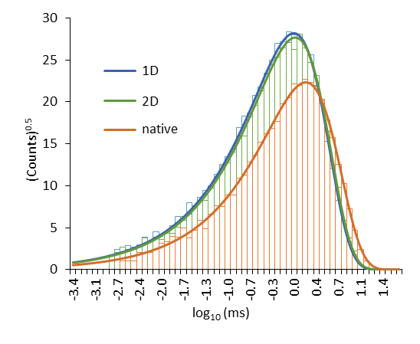
FIG. 8. Sigworth-Sine plot of forward passage times.
It is apparent from Fig. 8 that for both the native process and the two levels of coarse-graining, the binned dwell times faithfully followed the theoretical distribution across roughly four orders of magnitude. Even with binning error, fits of the Sigworth-Sine plot using the adjustable value τ_{fit} yielded results very close to the averaged τ₁ (Table I). The macroscopic two-state approximation for small (N ~ 400) kinetic Ising systems is evidently a good one.

TABLE I. Forward Mean First Passage Times from Monte Carlo simulation.
 | Native | 2D | 1D
counts | 6,776 | 10,397 | 10,791
τ₁ (ms) | 1.672 ± 0.020ª | 1.145 ± 0.011ª | 1.086 ± 0.010ª
k₁₂ (kHz) | 0.5982 ± 0.0073^{b} | 0.8735 ± 0.0085^{b} | 0.9210 ± 0.0088^{b}
τ_{fit} (ms) | 1.675 | 1.146 | 1.088
ªstandard error (τ₁) = τ₁/counts^{½} (property of exponential distribution).
^{b}standard error (k₁₂) = (k₁₂/τ₁)s.e.(τ₁).
The coarse-grained representations (1D and 2D) predicted significantly smaller values of τ₁ than the native process, and therefore a larger k₁₂. The 2D landscape yielded a marginally more accurate result than the 1D landscape. These are the major findings of our study.
- Comparing numerical methods
In the 1D and 2D representations, we checked the Monte Carlo estimate for k₁₂ against the eigenvalue and MFPT methods. There was generally excellent agreement between the three calculations for both 1D and 2D cases. There were some mild discrepancies (Fig 6b). In two cases where the PMF barrier was quite large (T = 17 °C and N = 484), the Monte Carlo estimates were slightly larger than the other two methods, independent of which “good” pseudorandom number generator was used. Regardless of these minor differences, equal weights were given to the three methods in determining the average k₁₂ for both 1D and 2D coarse-graining
- Rate constants as a function of N, T, and V
The dependence of k₁₂ on structural and environmental variables N, T, and V can be predicted from the shapes of 1D energy and diffusion landscapes shown in Fig. 9. Reactive rate theory predicts that k₁₂ should decrease exponentially with forward barrier height ΔF and increases linearly with maximum D, with the relative curvatures around state 1 and the barrier making minor contributions (Sigg, 2014). In the electrical Ising model, the value of ΔF increased with increasing N and decreased with increasing T and V. The peak value of D increased substantially with increasing N, more slowly with increasing T, and was negligibly dependent on V.
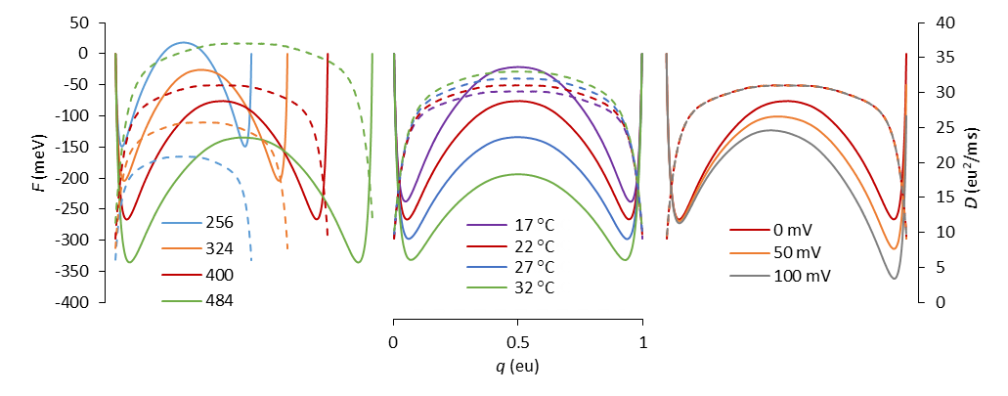
FIG. 9. Free energy (solid lines) and diffusion (dashed lines) landscapes as a function of model parameters (left plot, N; middle plot, T; right plot, V). The red curves correspond to the reference model (N = 400; T = 22 °C; V = 0 mV). Landscapes were calculated from ensemble averaged mesoscopic rate constants, but time averaging of Monte Carlo trajectories yielded nearly identical results.
We wanted to know if the substantial overestimation of macroscopic rate constants after coarse-graining was consistent across all environmental conditions, so we compared the Monte Carlo-derived values for the native process with the averages of Monte Carlo, eigenvalue, and MFPT estimates for the 1D and 2D coarse-grained models at different N, T and V. The results are shown in Fig. 10.
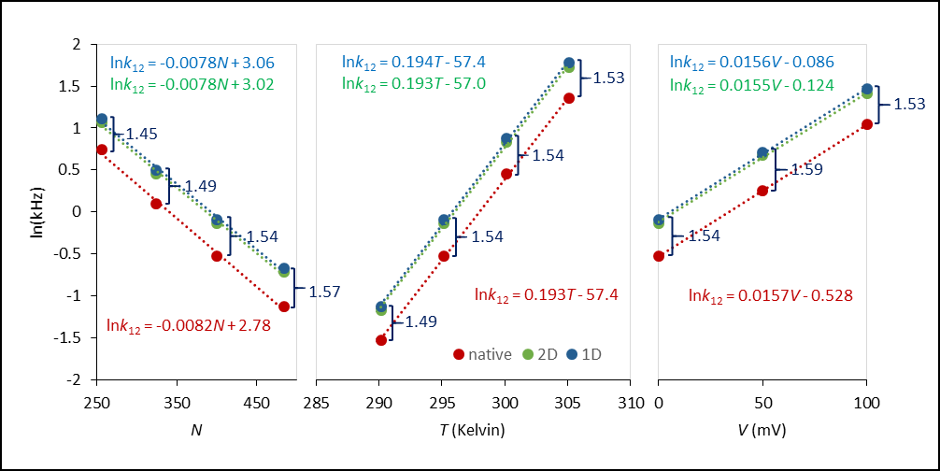
FIG. 10. Linear regression analysis in the semilog plot of forward rate constants with respect to the same environmental conditions as in Fig 9. The native rate constants were calculated as the inverse means of Monte Carlo first passage times from q₁ to q₂, as described in the text. The 1D and 2D rate constants were averaged from their respective Monte Carlo, mfpt, and eigenvalue calculations. Error bars from six experiments are plotted but do not exceed the size of the markers. The linear regression equations are color-matched to their respective data. The ratio of 1D to native rates are shown in blue for each set of conditions.
The results show that under all simulated conditions, the coarse-grained (1D and 2D) estimates of forward rate constants were about 50% greater than the native rate constant, with 1D rates again slightly greater than their 2D counterparts. The approximate 3:2 ratio was fairly consistent across all conditions, though there was a small tendency towards larger ratios with increasing system size (N). Linear fits describing the relationships lnk₁₂ = cX + d, with X representing either N, T, or V, resulted in nearly identical slopes c for native, 1D, and 2D calculations. The slopes have physical significance. From the lnk₁₂ vs. N plots, we determine that every added particle increases the barrier by 0.2 meV. The lnk₁₂ vs. T and lnk₁₂ vs. V plots are consistent with a forward activation charge of 0.4 eu and forward activation energy of 1450 meV.
These findings suggest that for a range of applied constraints, the overestimation of rate constants caused by coarse-graining could be corrected using a constant factor, which for this model was roughly 1.5. The small difference between 1D- and 2D-derived values of k₁₂ can be attributed to the energy-directed curvature in the 2D reaction pathway (Fig. 2). There is presumably some dynamic information lost when the 2D landscape is projected onto a 1D pmf.
V. DISCUSSION
The inspiration for this study came about when one of us (DS) attempted to construct a 1D diffusion landscape consisting of W(q) and D(q) for the kinetic Ising model. Efforts to compute the correct native transition rate from the coarse-grained landscape failed regardless of what method (Monte Carlo, Langevin, MFPT, or eigenvalue) was used. Initially thinking the problem lay with the 1D projection along q, we expanded to a 2D representation in q and E. This provided a complete solution of Ising thermodynamics, but offered only a small improvement when calculating the macroscopic rate. It became clear that the culprit was the manner in which microscopic rates were averaged at the mesoscopic level. What works for thermodynamics does not necessarily work for kinetics.
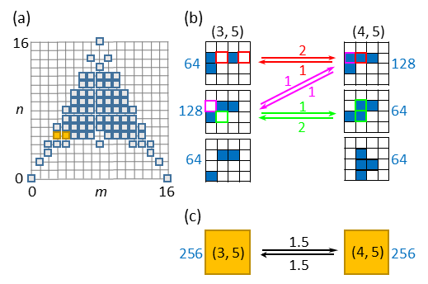
FIG. 11. (a) Mesoscopic (m, n) grid for the 4 x 4 Ising model. The (3, 5) and (4, 5) mesostates are colored yellow. (b) Microstate sub-groups compatible with the (3, 5) and (4, 5) states. Blue cells are activated. The number of microstates (g_{i}) in each sub-group are shown adjacent to typical configurations. Allowed transitions between sub-groups are indicated by arrows that are labeled with the number (= microscopic frequency factor) of color-matched cells that contribute to the transition. (c) The mesoscopic transition scheme, where the averaged frequency factors = 1.5 are the ⟨r⟩ rates discussed in the Theory section.
Our methods do not reveal the precise source of error in coarse-graining, but a clue may be found by analyzing in detail a single transition of a smaller Ising system (Fig. 11). The mesoscopic (3, 5) ↔ (4, 5) transition of the 4 x 4 Ising model (N = 16) moves one increment of charge but leaves energy unchanged. Both the (3, 5) and (4, 5) mesostates contain g = 256 microconfigurations. Both mesostates split into three sub-configurations, of which two (g₁, g₂) experience transitions to the opposing mesostate. These transition-capable sub-states contribute to the mean rate constant in proportion to the product of g_{i}/g and a microscopic frequency factor (the number of transition paths available to the sub-state). The averaged product is the mesoscopic frequency factor ⟨r⟩. The third sub-group, comprising a quarter of microconfigurations in each mesostate, does not participate in the reaction at all because there are no transition paths available. This sub-group does not contribute to the mean rates, and should the system find itself in one of its microstates, a path to a different energy state must be taken. This suggests that for the native process, trajectory pathways are on average a bit longer than predicted by the coarse-grained representation. We conjecture that the additional pathway length is responsible for the slower rates in the native process.
In proteins, there is the concept of frustration, in which trajectories become trapped in blind end states of varying energy depth, leading to low-temperature power-law distributions in reaction rates (Frauenfelder et al., 1991). The simple Ising process does not experience frustration in the same way, since movement in either direction of the order parameter q is always possible, but the inaccessibility of some micro-configurations pathways could be viewed as a minor form of frustration.
One may question whether mesoscopic averaging is an optimal method for coarse-graining the kinetic Ising model. An argument in favor of the microcanonical method is that it completely specifies N-particle thermodynamics for any values of T and V, though calculations are limited to observables that are functions of q and E. We chose a form of microscopic rate constant that satisfies the requirement of q- and E-dependency, but whose averaging depends on microscopic transition pathways in a way that thermodynamic averaging does not. The kinetics at the mesoscopic level are represented by a master equation, but we showed in the 1D projection that the master equation can be represented by a diffusion landscape, and the same would apply to the 2D model. The landscape approach to kinetics is typical for protein studies, where sampling of the configuration space using molecular or Langevin dynamics is used to generate a potential of mean force (Harpole and Delemotte, 2017). Fluctuation analysis combined with umbrella sampling can be used to generate a diffusion constant that may be spatially dependent or even have memory for past events (Straub et al., 1987). We attempted to use a similar fluctuation analysis of native Ising dynamics using Nyquist’s theorem to measure D at the barrier peak, but the results are more compatible with the coarse-grained value of D than with the effective native value (Fig. 5). It is possible that, due to configurational frustration, any coarse-graining method using ensemble averaged rate constants will persistently underestimate the macroscopic rate constant. In the case of the Ising model, it is encouraging that the approximate 3:2 ratio of calculated to “native” rates appears fairly constant across conditions that would be considered physiological, suggesting that for practical purposes the kinetics is “solved” under these conditions, provided one employs the correct scale factor. It remains to be seen whether this scale factor can be derived mathematically.

ACKNOWLEDGMENTS

REFERENCES
Belardinelli, R.E., and V.D. Pereyra. 2007. Fast algorithm to calculate density of states. Phys. Rev. E. 75:46701. doi:10.1103/PhysRevE.75.046701.
Best, R.B., and G. Hummer. 2010. Coordinate-dependent diffusion in protein folding. Proc. Natl. Acad. Sci. 107:1088–1093. doi:10.1073/pnas.0910390107.
Frauenfelder, H., S. Sligar, and P. Wolynes. 1991. The energy landscapes and motions of proteins. Science (80-. ). 254:1598–1603. doi:10.1126/science.1749933.
Glauber, R.J. 1963. Time‐Dependent Statistics of the Ising Model. J. Math. Phys. 4:294–307. doi:10.1063/1.1703954.
Harpole, T.J., and L. Delemotte. 2017. Conformational landscapes of membrane proteins delineated by enhanced sampling molecular dynamics simulations. Biochim. Biophys. Acta - Biomembr. 0–1. doi:10.1016/j.bbamem.2017.10.033.
Van Kampen, N.G. 1992. Stochastic Processes in Physics and Chemistry. 2nd ed. North-Holland Personal Library, Amsterdam.
L’Ecuyer, P. 1999a. Tables of linear congruential generators of different sizes and good lattice structure. Math. Comput. 68:249–261. doi:10.1090/S0025-5718-99-00996-5.
L’Ecuyer, P. 1999b. Good Parameters and Implementations for Combined Multiple Recursive Random Number Generators. Oper. Res. 47:159–164. doi:10.1287/opre.47.1.159.
Pleimling, M., and H. Behringer. 2005. Microcanonical analysis of small systems. Phase Transitions. 78:787–797. doi:10.1080/01411590500288999.
Press, W., S. Teukolsky, W. Vetterling, B. Flannery, E. Ziegel, W. Press, B. Flannery, S. Teukolsky, and W. Vetterling. 1992. Numerical Recipes in C. 2nd ed. Cambridge University Press, New York.
Reimann, P., G.J. Schmid, and P. Hänggi. 1999. Universal equivalence of mean first-passage time and Kramers rate. Phys. Rev. E. 60:R1–R4. doi:10.1103/PhysRevE.60.R1.
Saito, M., and M. Matsumoto. 2008. SIMD-Oriented Fast Mersenne Twister: a 128-bit Pseudorandom Number Generator. In Monte Carlo and Quasi-Monte Carlo Methods 2006. Springer-Verlag, Berlin, Heidelberg. 607–622.
Sigg, D. 2014. Modeling ion channels: Past, present, and future. J. Gen. Physiol. 144:7–26. doi:10.1085/jgp.201311130.
Sigg, D., H. Qian, and F. Bezanilla. 1999. Kramers’ Diffusion Theory Applied to Gating Kinetics of Voltage-Dependent Ion Channels. Biophys. J. 76:782–803. doi:10.1016/S0006-3495(99)77243-7.
Sigworth, F.J., and S.M. Sine. 1987. Data transformations for improved display and fitting of single-channel dwell time histograms. Biophys. J. 52:1047–1054. doi:10.1016/S0006-3495(87)83298-8.
Straub, J.E., M. Borkovec, and B.J. Berne. 1987. Calculation of dynamic friction on intramolecular degrees of freedom. J. Phys. Chem. 91:4995–4998. doi:10.1021/j100303a019.
Toda, M., R. Kubo, and N. Saitô. 1992. Statistical Physics I. Equilibrium Statistical Mechanics. 30. 2nd ed. Springer-Verlag, Berlin, Heidelberg.
Zheng, J., and M. Trudeau eds. . 2015. Handbook of Ion Channels. 1st ed. CRC Press, Boca Raton, FL. 691 pp.

